|  |
| --- |
|  |

|  |
| --- |
| **OPERATIONAL AMPLIFIERS** |
|  |
|  |
|  |
|  |
|  |
|  |
|  |

**What is a monolithic integrated circuit?**

1. An **integrated circuit** or **monolithic integrated circuit** (also referred to as an **IC**, a **chip**, or a **microchip**) is a set of electronic circuits on one small flat piece (or "chip") of semiconductor material, normally silicon.

2. It is an electronic circuit that is built on a single semiconductor base material or single chip.

3. The integration of large numbers of tiny transistors into a small chip resulted in circuits that are orders of magnitude smaller, cheaper, and faster than those constructed of discrete electronic components.

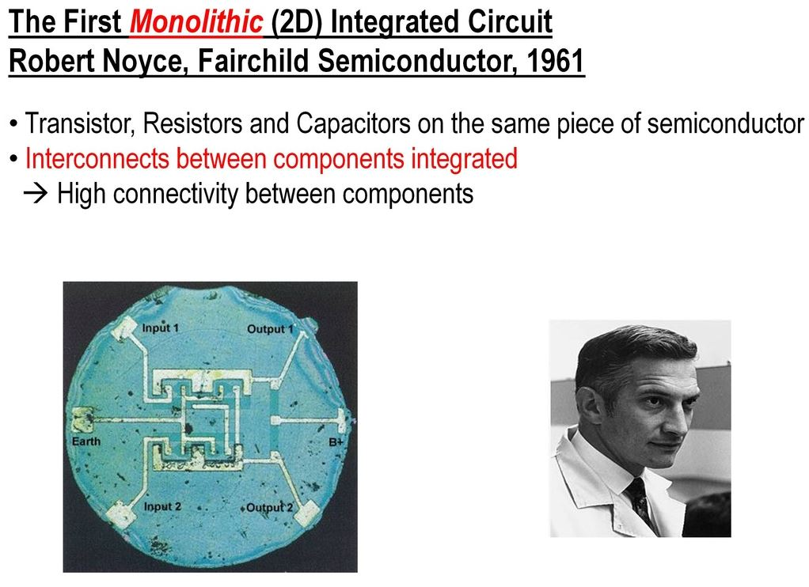

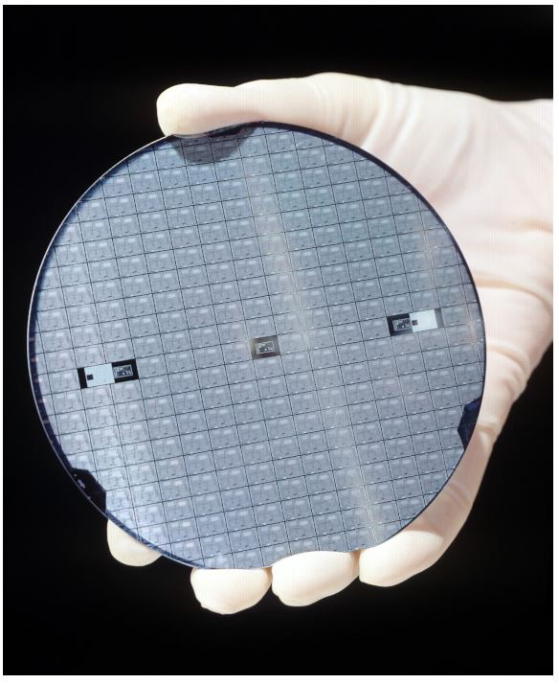

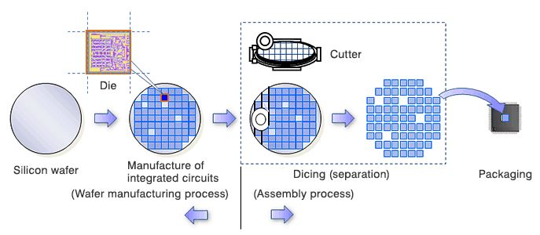

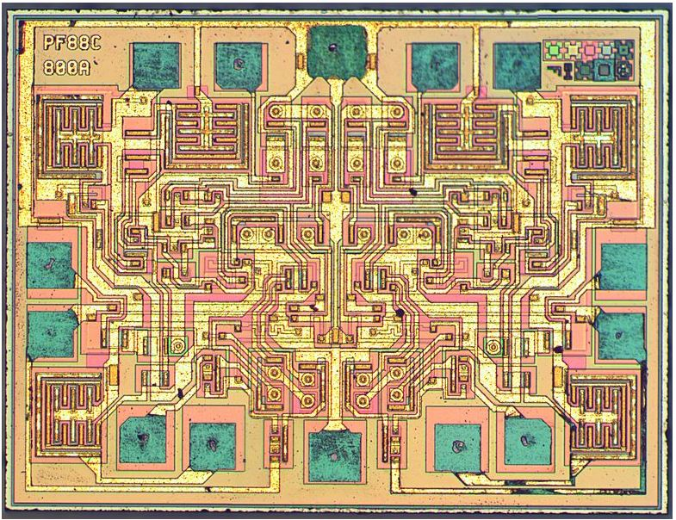

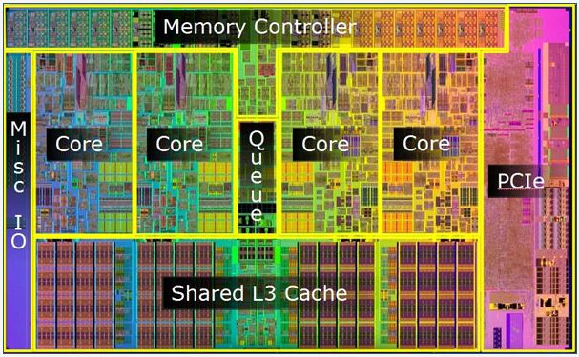

**Advantages of Monolithic ICs**

1. Miniature in size. Since  the active and passive components  are integrated on to a silicon chip using fabrication process , the IC becomes a lot smaller. When compared to a  discrete circuit, it may be at least a thousand times smaller.
2. Due to small size, the weight of the IC also reduces, when compared to the discrete circuit.
3. For the production of hundreds of IC’s the cost of production is very low and less time consuming. However,  to produce hundreds of discrete circuits on a PCB for  the same logic takes more time and increase the cost factor.
4. The PCB consisting soldered joints will be less reliable. This problem is omitted in IC’s because of no soldered joints, with fewer interconnections, and thus highly reliable.
5. The small size of IC’s causes lesser power consumption and lesser power loss.
6. In a discrete circuitry, if a single transistor becomes faulty, the whole circuit may fail to work. This transistor has to be desoldered and replaced. It is difficult to find out which component has failed. This problem can be omitted in an IC by replacing an entire IC as it is low in cost.
7. Increased operating speed because of absence of parasitic capacitance effect.
8. As the IC’s are produced in bulk the temperature coefficients and other parameters will be closely matching.
9. Improved functional performance as more complex circuits can be fabricated for achieving better characteristics.
10. All IC’s are tested for operating ranges in very low and very high temperatures.
11. As all the components are fabricated very close to each other in an IC, they are highly suitable for small signal operation, as there won’t be any stray electrical pickup.
12. As all the components are fabricated inside the chip, there will not be any external projections.

Since their invention, manufacturers have been manufacturing monolithic ICs to carry out all types of functions. Commercially available ICs of this type can be used as amplifiers, voltage regulators, crowbars, AM receivers, TV circuits and computer circuits.

**Disadvantages of Monolithic ICs**

However, the monolithic circuits have the following limitations or drawbacks:

1. Low power rating. Since monolithic ICs are of about the size of a discrete small signal transistor, they typically have a maximum power rating of less than 1 watt. This limits their use to low-power applications.
2. Poorer isolation between components.
3. No possibility of fabrication of inductors.
4. Small range of values of passive components used in the ICs.
5. Lack of flexibility in circuit design as for making any variation in the circuit, a new set of masks is required

# **Hybrid IC**

As the name implies, the circuit is fabricated by interconnecting a number of individual chips. The active components are diffused transistors or diodes. The passive components may be a group of diffused resistors or capacitors on a single chip or they may be thin-film components. Wiring or a metallized pattern provides connections between chips. Hybrid ICs are widely used for high power audio-amplifier applications from 5 W to more than 50 W.

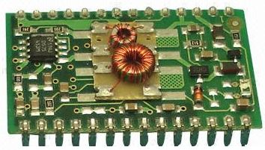

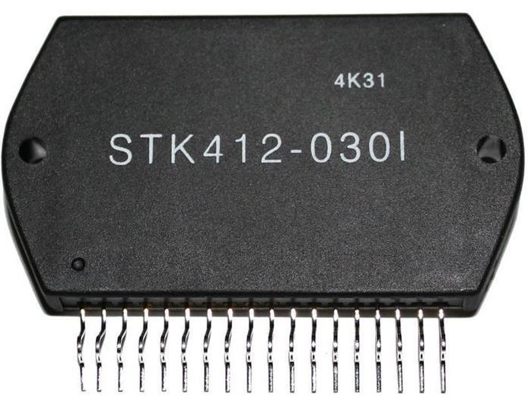

**What is an Op amp ?**

Op amp is the abbreviation of Operational Amplifier. An operational amplifier is a direct coupled high gain amplifier usually consisting of one or more differential amplifiers followed by a level transistor and an output stage. The output stage is generally push-pull or complementary symmetry push-pull amplifier.

Op amps are building blocks of analog circuitry and is also known as differential amplifier as its output depends on difference between input signals. It can also be used to amplify both DC as well as AC signals. Op-amp is primarily designed for old analog computers, where they were used for computing mathematical functions like addition, subtraction etc. By using suitable external feedback components op amp can be used for applications like amplifiers, oscillators, comparators etc.

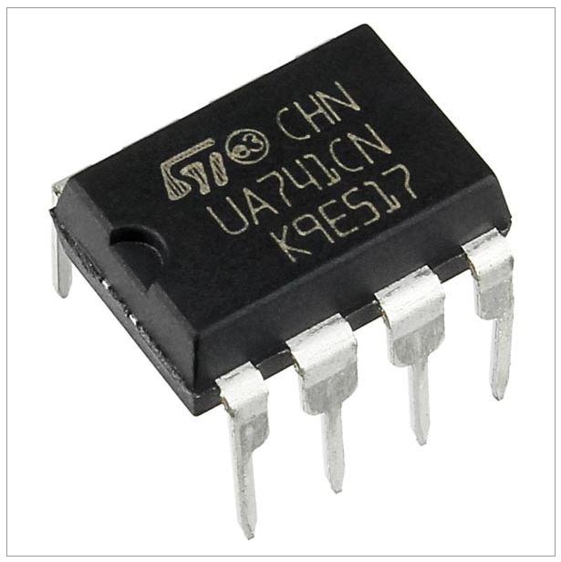

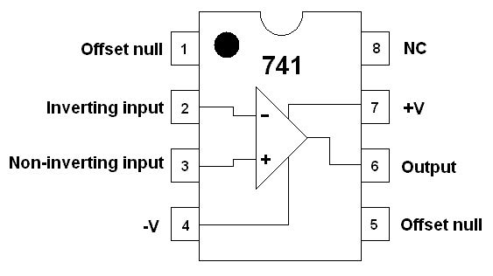

**What makes op amp different from other amplifiers?**

Op amp is a differential amplifier having very high gain. It has basically 2 inputs, **non-inverting input** (Vp or V+) and **inverting input** (Vn or V-). Op amp will amplify only the difference between these two inputs ie **(Vp – Vn)** or **(V+ – V-)**. Important features of op amp compared to normal amplifiers are given below.

* Very high gain
* Very high input impedance
* Very low output impedance
* High CMRR
* High bandwidth
* Able to amplify both AC and DC
* Low noise

**Block Diagram of Operational Amplifier**

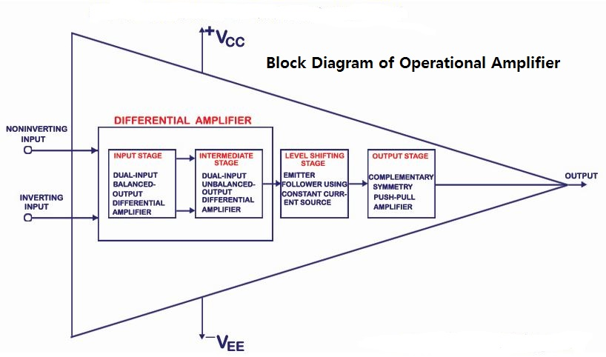

The Input Stage is a dual input balanced output differential amplifier which provides most of the voltage gain of amplifier and also establishes the input resistance of op-amp. Intermediate Stage is a dual input unbalanced output differential amplifier. DC voltage at the output stage will be above ground potential due to direct coupling. Therefore, a Level Shifting Stage is used to shift the dc level to zero. The Output Stage is usually a complementary push-pull amplifier which increases output voltage swing and current supplying capability of the op-amp. It also responsible for establishing low output resistance of the op amp.

• Input Stage

As explained above, Input Stage is a dual input balanced output differential amplifier which provides most of the voltage gain of amplifier and also establishes the input resistance of op-amp.

• Intermediate Stage

As explained above, Intermediate Stage is a dual input unbalanced output differential amplifier.

• Level Shifting Stage

Since op amps are direct coupled, dc level at the output will be above zero. Each amplifier stage produces AC amplification of the signal but at the same time the DC level is shifted due to the bias voltages. So we need to use level translator circuits to shift dc level to zero.

• Output Stage

This stage should be capable of supplying load current and should have low output resistance. Complementary push pull amplifier increases the output voltage swing of the output signal and also increases the current supplying capability of op-amp.

**Equivalent Circuit of uA 741**

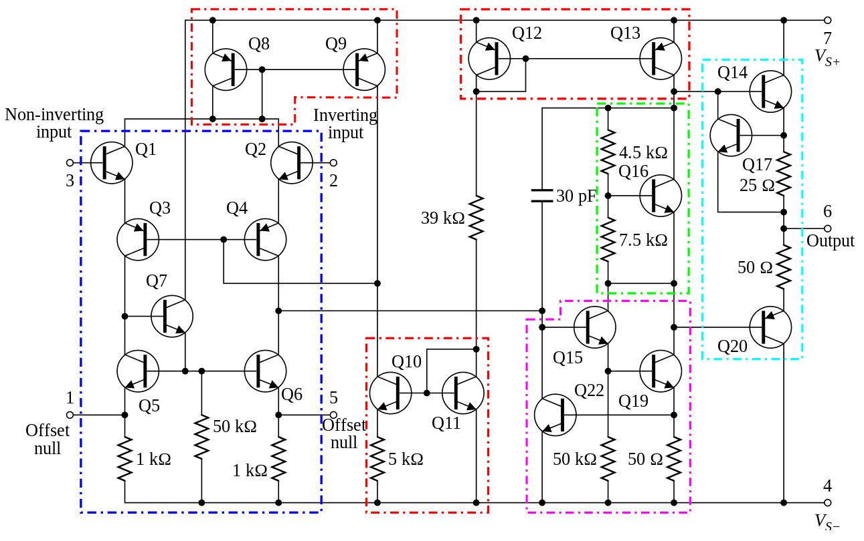

# **Op amp Symbol**

[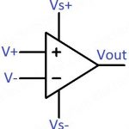](https://electrosome.com/wp-content/uploads/2016/08/OpAmp-Symbol.jpg)

The input signals at inverting terminal results in opposite polarity output where as the inputs signals at non-inverting terminal produces same polarity output.

**uA 741 Data Sheet**

[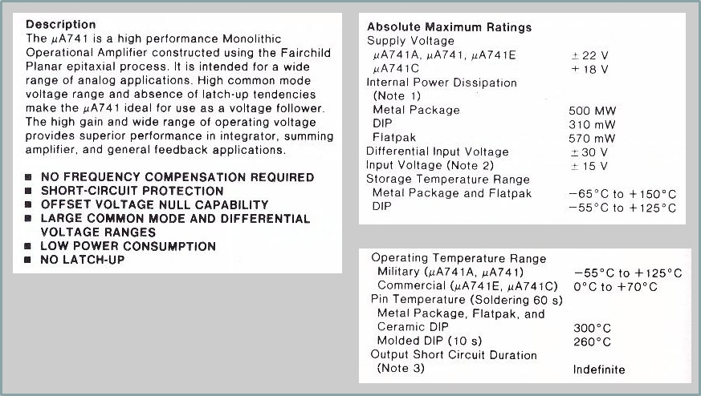](https://electrosome.com/wp-content/uploads/2016/08/OpAmp-Symbol.jpg)

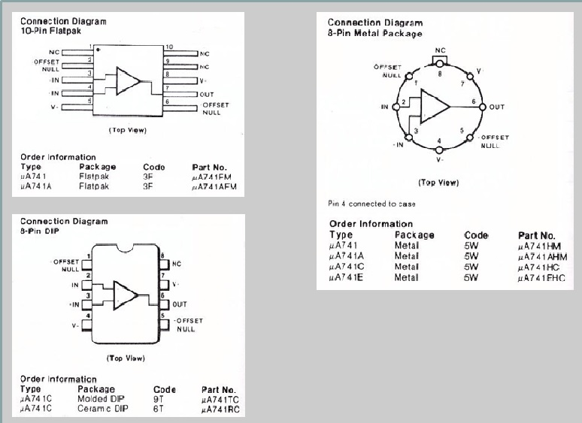

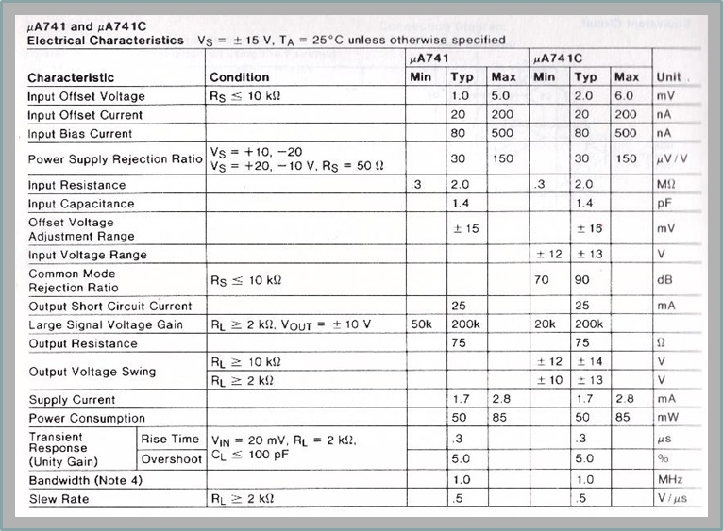

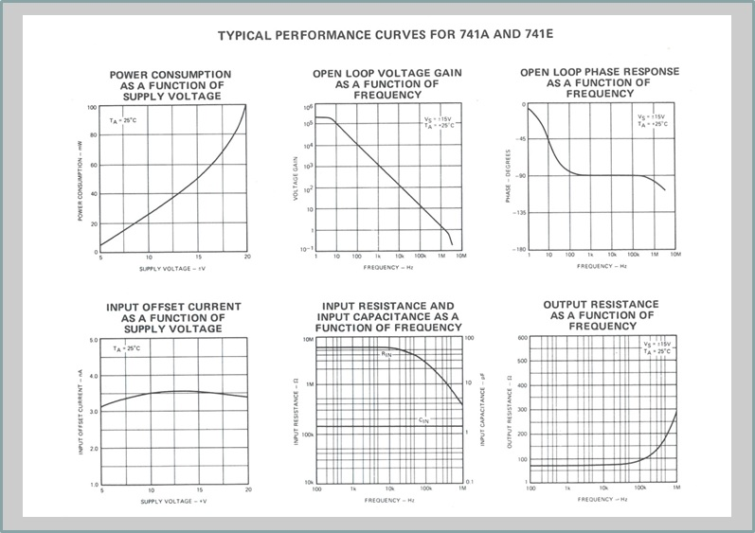

**Absolute Maximum Parameters:**  
Maximum means that the op-amp can safely tolerate the maximum ratings as given in the data section of such op-amp without the possibility of destroying it. The µA741 is a high performance operational amplifier with high open loop gain, internal compensation, high common mode range and exceptional temperature stability. The µA741 is short-circuit protected and allows for nulling of the offset voltage. The µA741 is manufactured by Fairchild Semiconductor.  
  
**Supply Voltage (+/-Vs):** The maximum voltage (positive and negative) that can be safely used to feed the op-amp.  
**Dissipation (Pd):** The maximum power the op-amp is able to dissipate, by specified ambient temperature (500mW @ 80° C).  
**Differential Input Voltage (Vid):** This is the maximum voltage that can be applied across the + and - inputs.  
**Input Voltage (Vicm):** The maximum input voltage that can be simultaneously applied between both input and ground also referred to as the common-mode voltage. In general, the maximum voltage is equal to the supply voltage.  
**Operating Temperature (Ta):** This is the ambient temperature range for which the op-amp will operate within the manufacutrer's specifications. Note that the military grade version (µA741)has a wider temperature range than the commercial, or hobbyist, grade version (µA741C).  
**Output Short-Circuit Duration:** This is the amount of time that an op-amp's ouput can be short-circuited to either supply voltage.  
  
**Summed-up Features:**

|  |  |
| --- | --- |
|  | • Internal Frequency Compensation |
|  | • Short Circuit Protection |
|  | • Offset voltage null capability |
|  | • Excellent temperature stability |
|  | • High input voltage range |
|  | **Input Parameters:**   1. **Input Offset Voltage (Voi)** This is the voltage that must be applied to one of the input pins to give a zero output voltage. Remember, for an ideal op-amp, output offset voltage is zero! 2. **Input Bias Current (Ib)** This is the average of the currents flowing into both inputs. Ideally, the two input bias currents are equal. 3. **Input Offset Current (Ios)** This is the difference of the two input bias currents when the output voltage is zero. 4. **Input Voltage Range (Vcm)** The range of the common-mode input voltage (i.e. the voltage common to both inputs and ground). 5. **Input Resistance (Zi)** The resistance 'looking-in' at either input with the remaining input grounded.   **Output Parameters:**   1. **Output Resistance (Zoi)** The resistance seen 'looking into' the op-amp's output. 2. **Output Short-Circuit Current (Iosc)** This is the maximum output current that the op-amp can deliver to a load. 3. **Output Voltage Swing (Vo max)** Depending on what the load resistance is, this is the maximum 'peak' output voltage that the op-amp can supply without saturation or clipping.   **Dynamic Parameters:**   1. **Open-Loop Voltage Gain (Aol)** The output to input voltage ratio of the op-amp without external feedback. 2. **Large-Signal Voltage Gain** This is the ratio of the maximum voltage swing to the charge in the input voltage required to drive the output from zero to a specified voltage (e.g. 10 volts). 3. **Slew Rate (SR)** The time rate of change of the output voltage with the op-amp circuit having a voltage gain of unity (1.0).   **Other Parameters:**   1. **Supply Current** This is the current that the op-amp will draw from the power supply. 2. **Common-Mode Rejection Ratio (CMRR)**  A measure of the ability of the op-amp' to reject signals that are simultaneously present at both inputs. It is the ratio of the common-mode input voltage to the generated output voltage, usually expressed in decibels (dB). 3. **Channel Seperation** Whenever there is more than one op-amp in a single package, like the 747 op-amp, a certain amount of "crosstalk" will be present. That is, a signal applied to the input of one section of a dual op-amp will produce a finite output signal in the remaining section, even though there is no input signal applied to the unused section |

### **Characteristics of an Ideal Op amp**

[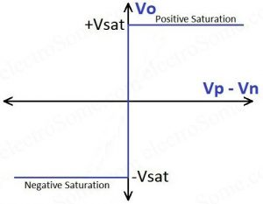](https://electrosome.com/wp-content/uploads/2016/08/Ideal-Op-Amp-Transfer-Characteristics.jpg)

Ideal Op-amp Transfer Characteristics

* Infinite open loop voltage gain
* Infinite input impedance
* Zero output impedance
* Infinite bandwidth
* Zero input offset voltage
* Zero common mode gain
* Infinite CMRR (Common Mode Rejection Ratio)
* Zero DC output offset
* Zero noise contribution
* Infinite power supply rejection ratio
* Positive and negative voltage swings to supply rail
* Output swings instantly to the correct value

**Real Op amp**

[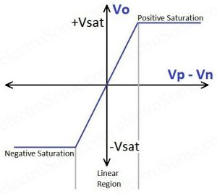](https://electrosome.com/wp-content/uploads/2016/08/Op-Amp-Transfer-Characteristics.jpg)

Real Op amp Transfer Characteristics

## **Real vs Ideal Op amp**

|  |  |  |
| --- | --- | --- |
| **Parameter** | **Ideal Op amp** | **Real Op amp** |
| Voltage Gain | ∞ | 105 ~ 109 |
| Input Resistance | ∞ | 106‎Ω (BJT) 109 ~ 1012‎‎Ω (FET) |
| Output Resistance | 0 | 100 ~ 1000Ω |
| Common Mode Gain | 0 | 10-5 |
| Gain Bandwidth Product | ∞ | 1 ~ 20MHz |

**Design Method for Direct Coupled Inverting Amplifier**

[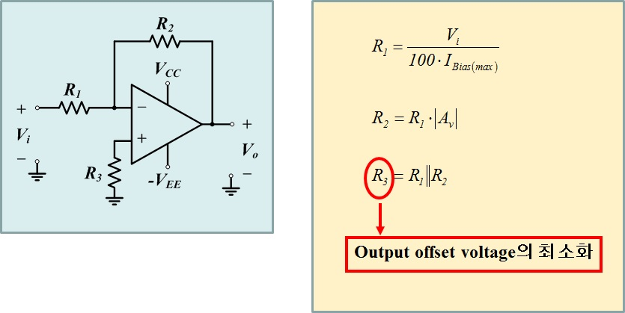](https://electrosome.com/wp-content/uploads/2016/08/Op-Amp-Transfer-Characteristics.jpg)

**Minimize Output Offset Voltage Technique**

[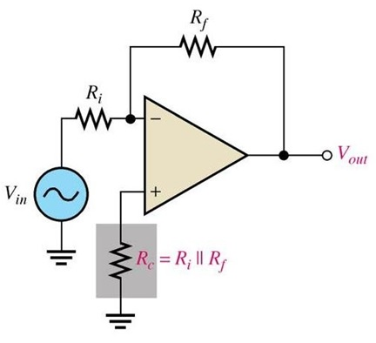](https://electrosome.com/wp-content/uploads/2016/08/Ideal-Op-Amp-Transfer-Characteristics.jpg)

**Design method of Capacitor Coupled Inverting Amplifier**

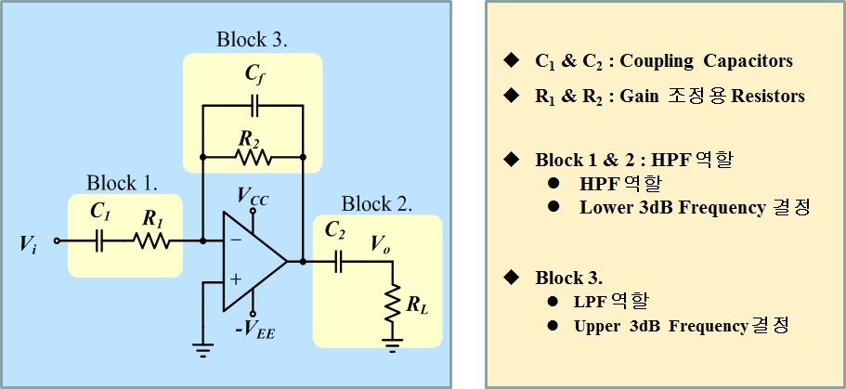

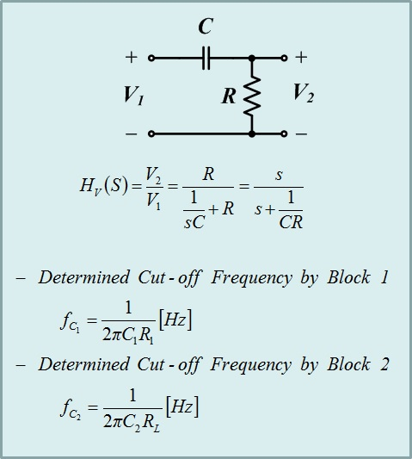 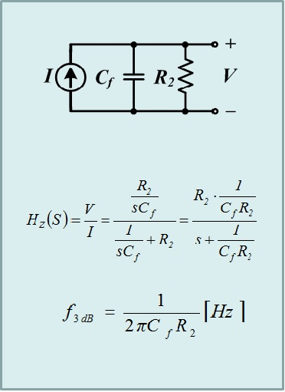

**(Design Example)**

Design a capacitor coupled inverting amplifier with Load resistance = 250Ω, Band width = 10~1kHz, Gain = 50, and Output voltage amplitude = 2.5V

**Design Method for Direct Coupled Non-inverting Amplifier**

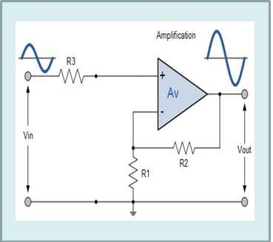

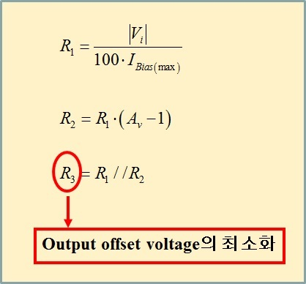

**Design method of Capacitor Coupled Noninverting Amplifier**

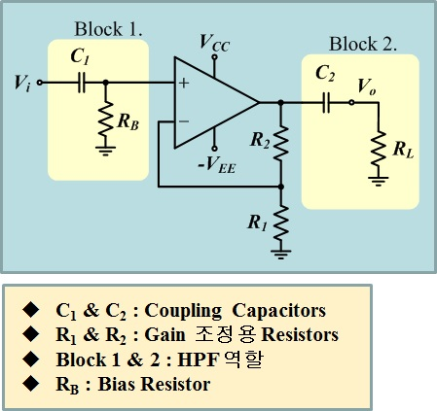

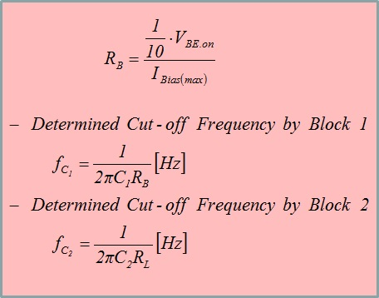

**Frequency Responses of Capacitor Coupled Noninverting Amplifiers**

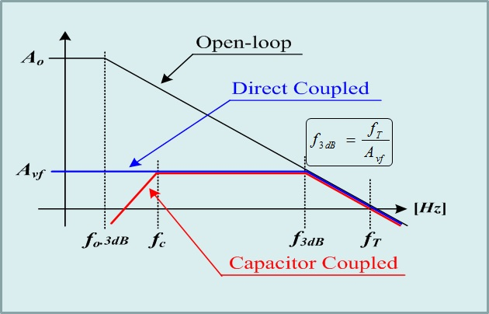

**(Design Example)**

Design a capacitor coupled non-inverting amplifier.

Load resistance = 2.2kΩ

Lower cutoff freq. = 120Hz

Gain = 66 of 15mV input signal amplitude

**Design Method for Single Supply Voltage Amplifier**

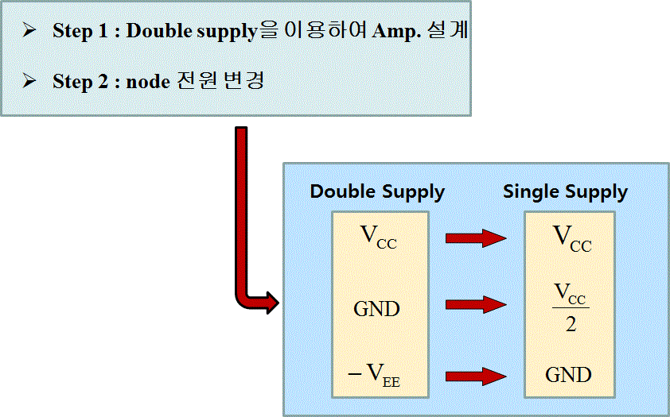

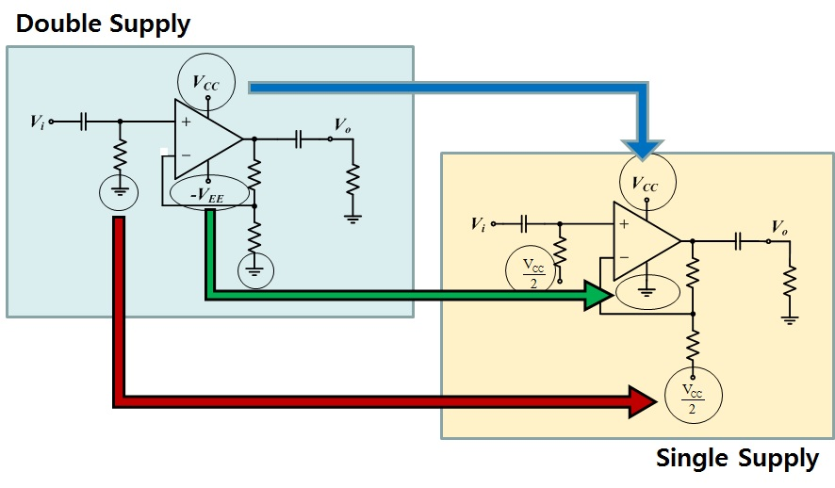

**Example 1.**

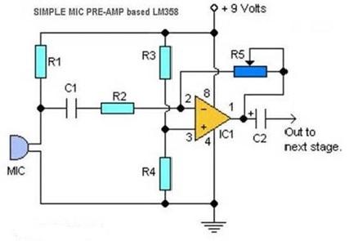

**Example 2.**

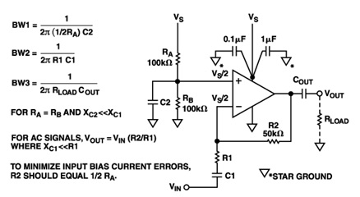

**Inverting Summing Amplifier**

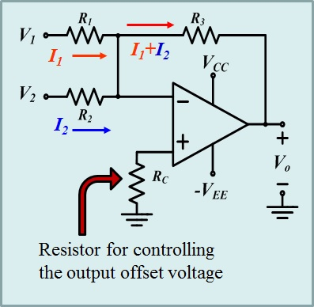

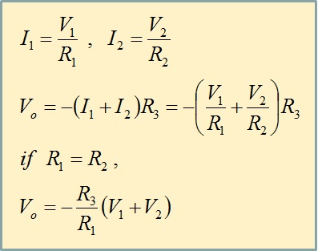

**(Desig Example)**

Design a summing amplifier to give the direct sum of two inputs which each range from 0.1V to 1V. Use uA741 Op-amp.

**Noninverting Summing Amplifier**

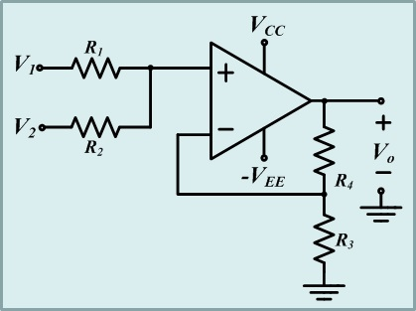

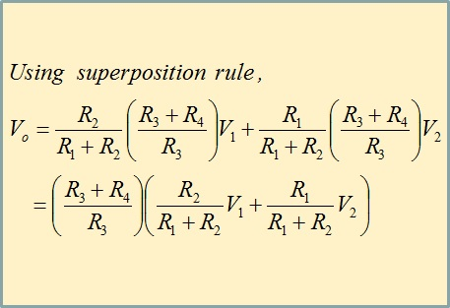

**Example 1. Audio Mixer**

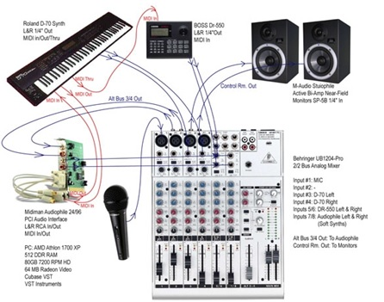

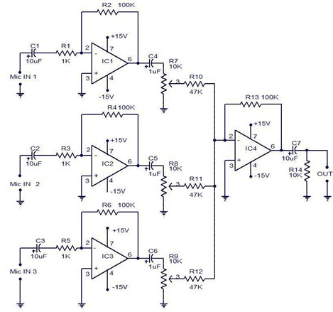

**Difference Amplifier**

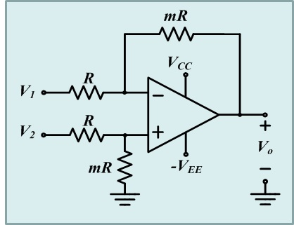

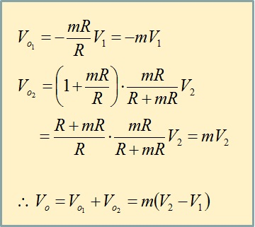

**Differential Amplifier**

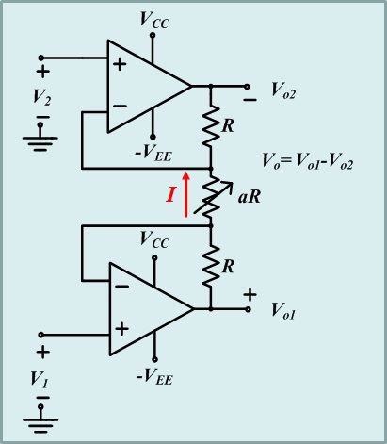 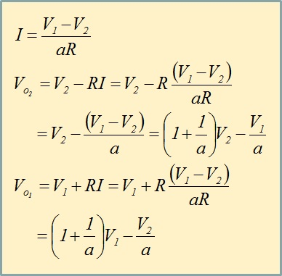

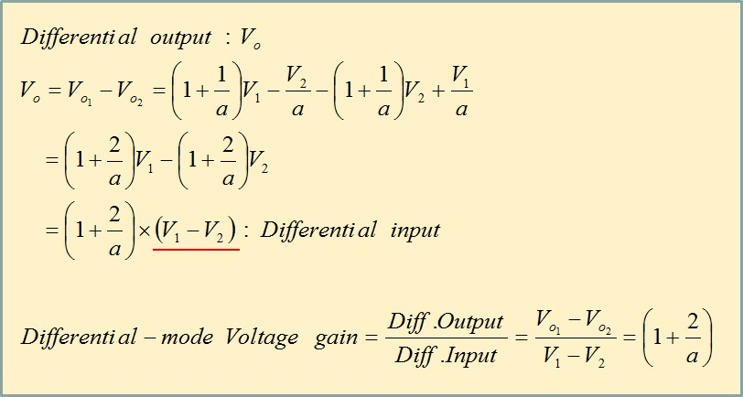

**Instrumentation Amplifier**

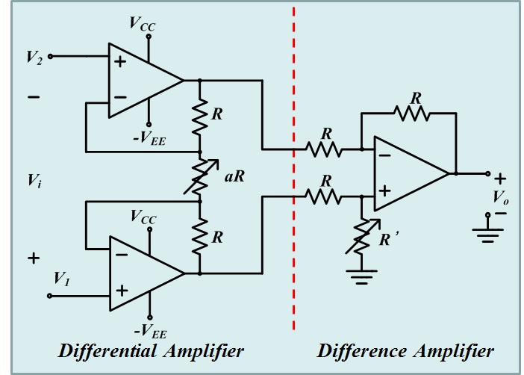

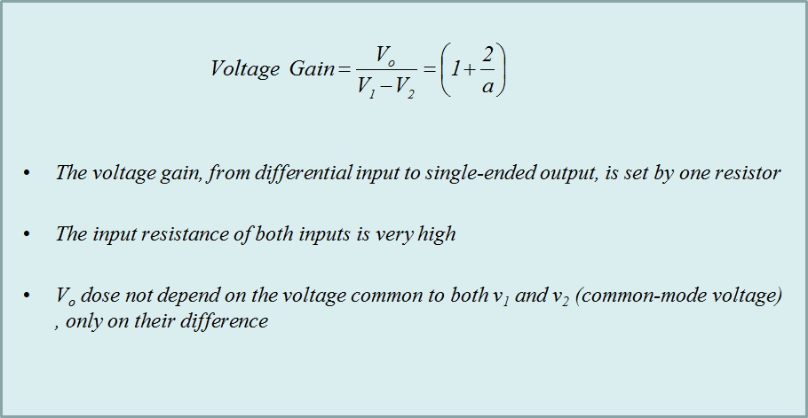

**Example 1. ECG**

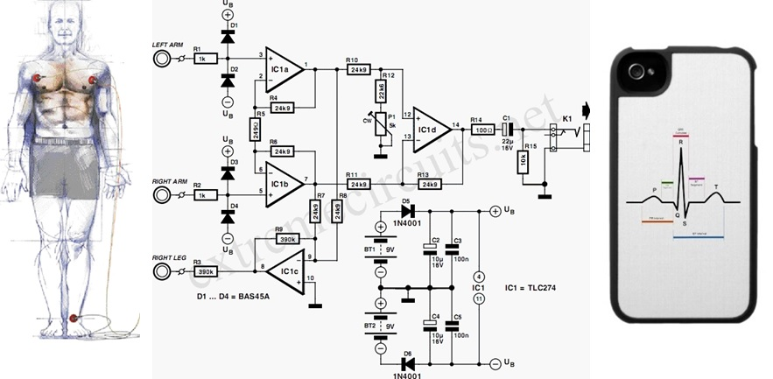

**Example 2. Deign of Instrumentation Amplifier**

Design an instrumentation amplifier to have an overall voltage gain of 1000. The input signal (differential input) amplitude is 5mV, u741 op-amps are to be used, and the supply is -15V and +15V**.**

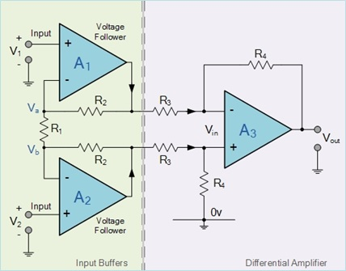

**RC Differentiator**



Frequency Response of RC Differentiator







**Basic Differentiator Structure**





Frequency Response of Basic Differentiator





**Practical Differentiator**





Frequency Response of Practical Differentiator





**(Design Example)**

아래 주어진 설계사양에 부합되는 differentiator를 설계하시요.

사용할 op-amp. : uA741, Power supply : +12 V & -12 V, 부하저항 : 10 kΩ

Input signal : 10 ~ 1kHz sine wave Amplitude of input : 1 V



**RC Integrator**

 

**Frequency Response of RC Integrator**





**Basic Integrator Structure**

 

**Frequency Response of Basic Integrator**



**Practical Integrator**

 

**Frequency Response of Practical Integrator**







**Case 2.** Input is rectangular wave



**(Design Example)**

아래 설계사양에 부합하는 integrator를 설계하시오.

사용할 op amp : uA 741

Power Supply : -15 ~ +15 V

Input Signal : Rectangular wave with 50% of duty cycle (T=2 ms, Peak-to-peak voltage= 10 V)

Output Signal = 4 V triangle wave (Peak-to-peak voltage)



(Example)

